## Skill-React

# React Hands-on Lab: Eventexamplesapp

# Code:

## Terminal Instructions:

**# 1. Create a new React app with the given project name**

**npx create-react-app eventexamplesapp**

**# 2. Move into the project directory**

**cd eventexamplesapp**

**# 3. Start the development server**

**npm start**

## Code(App.js):

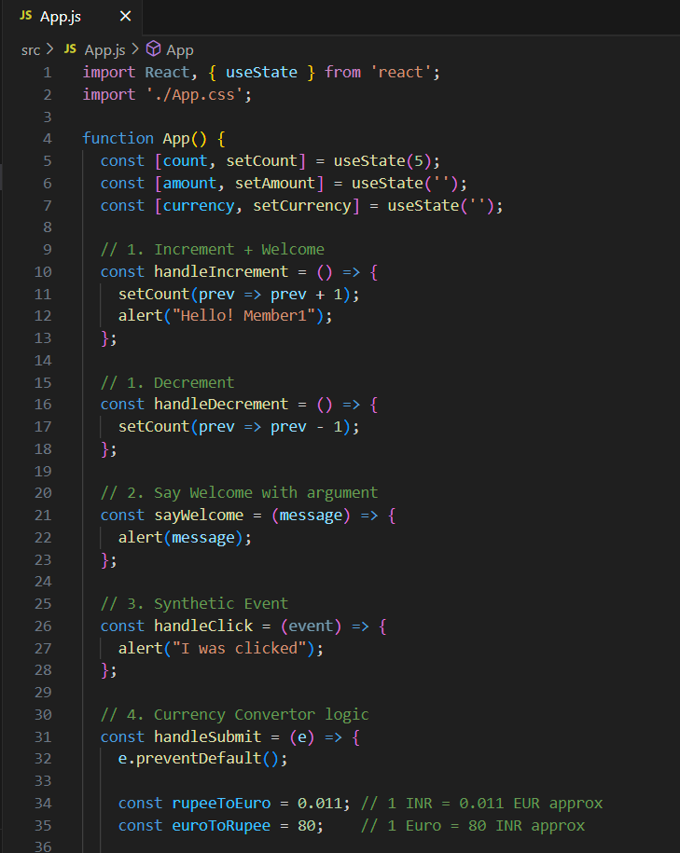

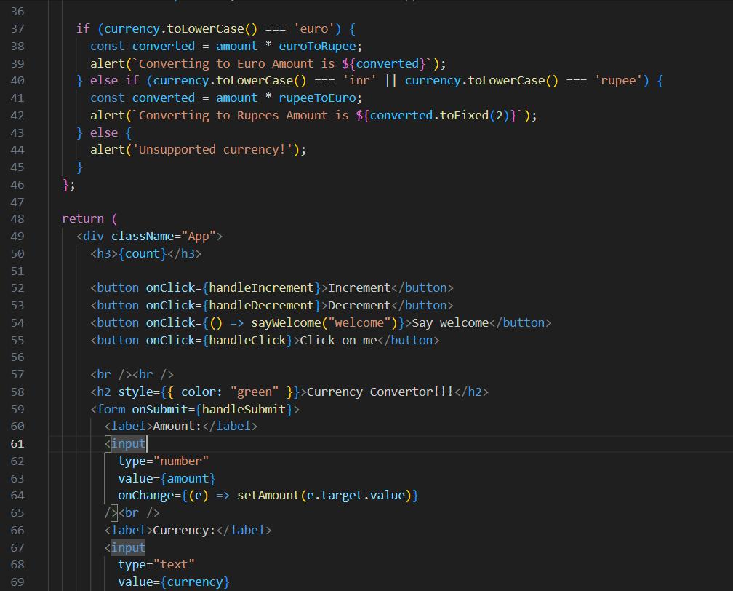

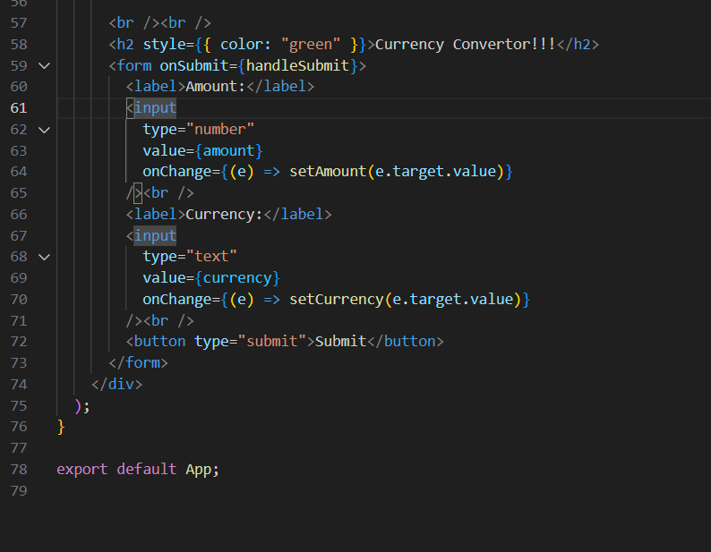

# Output:

